Anthropogenic Impacts on Deep Sea

Let’s say you are a photon and you are going deep into the sea. You will be able to travel without any difficulties up to 100 meters (330 feet) which is called the Euphotic zone (eu*good, photos*light). Up next, where a small but measurable quantity of yours will be found until you reach 1000 meters (3300 feet) named the Disphotic zone (dis*apart, photos*light). Below this you would not be found and which is called the Aphotic zone (a*without, photos*light). Here, below 200 meters is considered to be the start of the deep sea.¹

Now, The question is, how come humans are making an impact if the deep sea is so deep?

The deep sea is the largest ecosystem on earth which covers approximately 70% of the Earth’s solid surface and represents 90% of the oceans by volume. ² And, people are using the ocean as their wish without maintaining proper guidelines. From the era of industrialization and up until now, the era of technological advancement, humans significantly use the sea resulting in major effects on the deep sea.

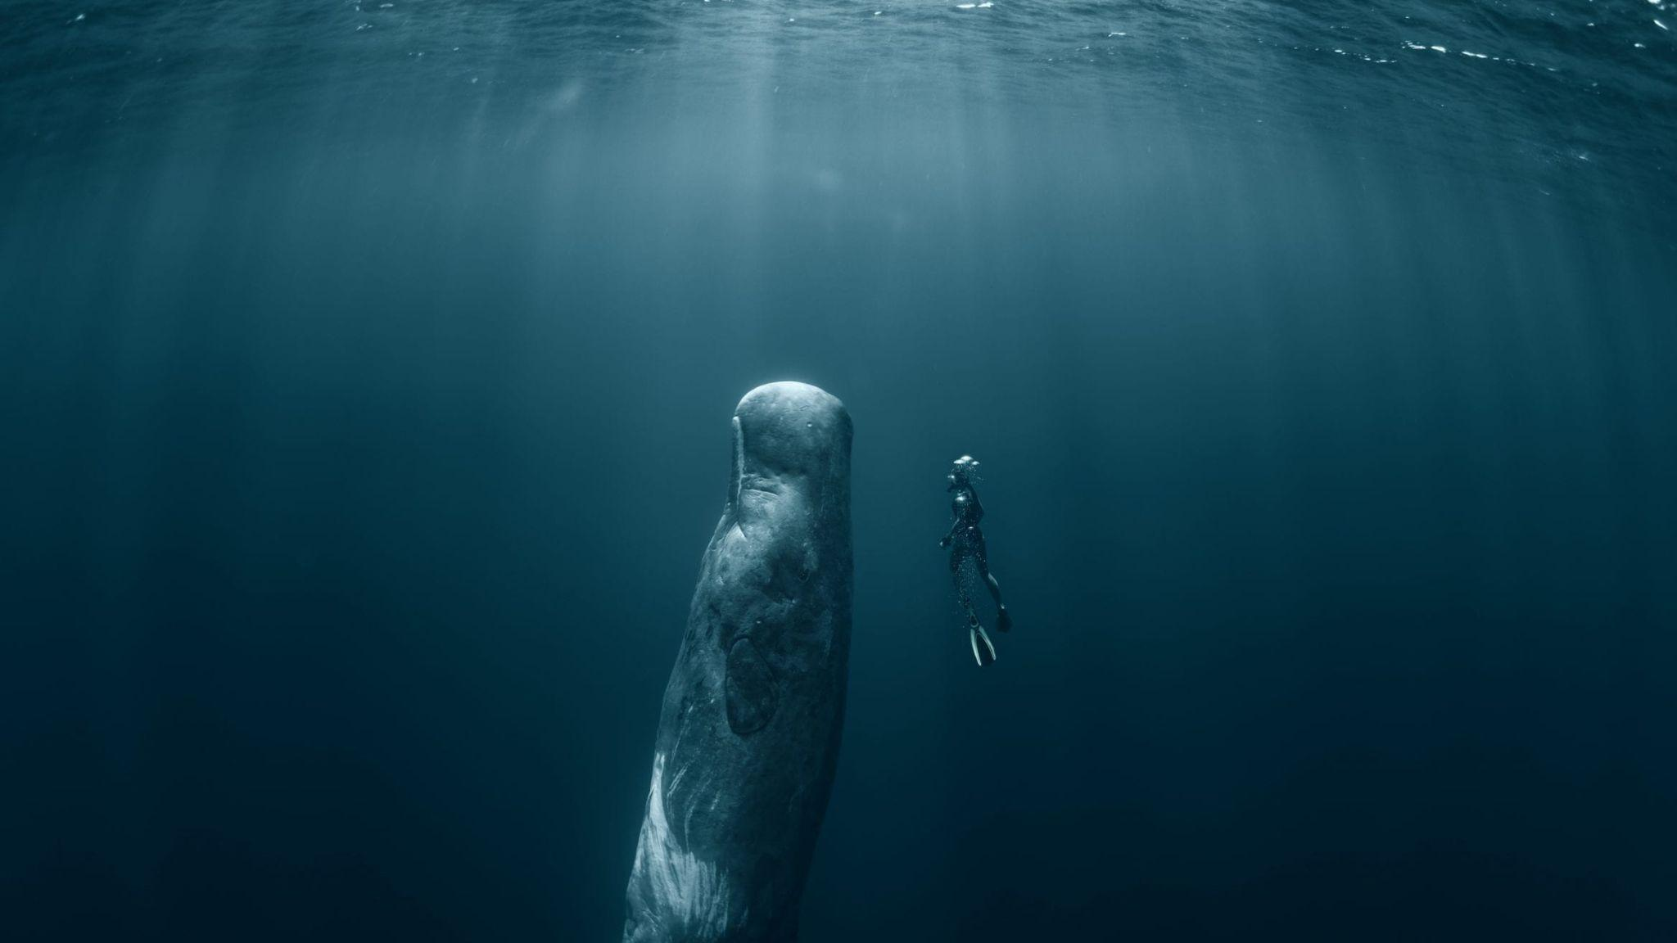
Image: The deep sea | Image courtesy: naturalworldfacts.com

- National Oceanic and Atmospheric Administration (NOAA). (n.d.). What is the deep sea? NOAA Ocean Exploration. https://oceanexplorer.noaa.gov/facts/deep-sea.html
- Ramirez-Llodra, E., Tyler, P. A., Baker, M. C., Bergstad, O. A., Clark, M. R., Escobar, E., Levin, L. A., Menot, L., Rowden, A. A., Smith, C. R., & Van Dover, C. L. (2007). Deep-sea chemosynthesis-based ecosystems: A review. Trends in Ecology & Evolution, 22(11), 626–634. https://doi.org/10.1016/j.tree.2007.08.002
Historically, the deep sea has been a disposal warehouse for various waste, including sewage, dredged materials, and industrial litter. This practice has given access to microplastics and toxic chemicals to affect deep sea habitats. Recently, some researchers have found the presence of microplastics even from the penguins living in the Antarctic region.³

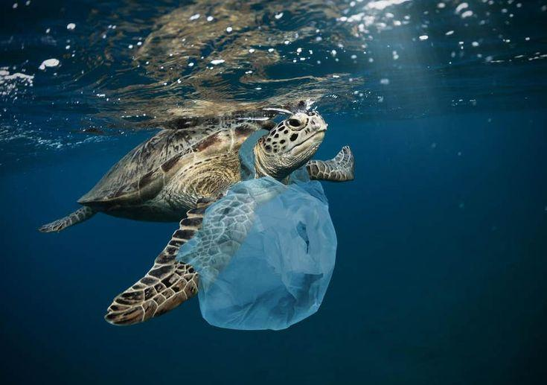
Image: Pollution in the deep sea | Image courtesy: pinterest.com

“Dead zones" in the deep sea, also known as hypoxic zones, are areas with dangerously low oxygen levels, making them uninhabitable for most marine life, often caused by excess nutrient pollution leading to algal blooms and subsequent oxygen depletion. This results in disruption of the marine food webs, loss of biodiversity in that area and habitat degradation. As the deep sea is still unexplored, it is not possible to determine the impact level but it is surely making a massive change just if we look at the level of pollution.

- Fossi, M. C., Baini, M., Ercoli, C., Casini, S., Campani, T., Marsili, L., & Clarkson, L. (2019). Microplastics in gentoo penguins from the Antarctic region. Polar Biology, 43(1), 183–188. https://doi.org/10.1007/s00300-019-02425-w

Nowadays, the most alarming factor is climate change and humans are the one to blame. The temperature of the sea water is rising day by day which can affect the metabolic rates and the biological processes of the deep-sea ecosystem.⁴ Climate change can also alter the ocean circulation affecting the amount of organic matter that sinks to the deep sea, which is called ‘“Marine Snow”. Marine snow is often called “Ocean Dandruff”. ⁵

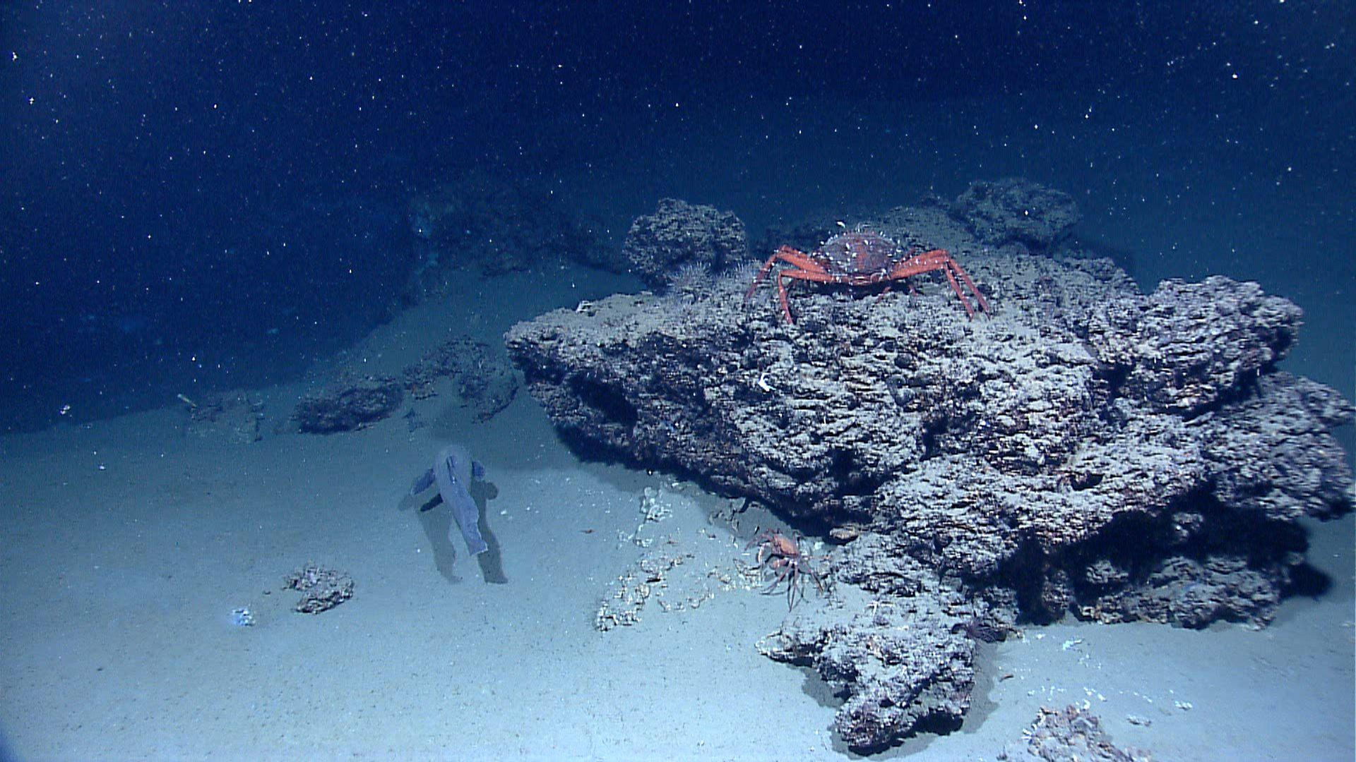
Image: Marine Snow | Image courtesy: MBARI (Monterey Bay Aquarium Research Institute)

An interesting thing about marine snow is, when it sinks it carries carbon with it, effectively moving it from the upper ocean. This process is called “Biological Carbon Pump”.⁶ The marine snow that isn't consumed eventually settles on the ocean floor, forming a thick layer of sediment known as “ooze”.⁷

- Sweetman, A. K., et al. (2016). Impacts of climate change on deep-sea benthic ecosystems. Earth-Science Reviews, 159, 19–46. https://doi.org/10.1016/j.earscirev.2016.06.004
- Smith, K. L., et al. (2022). Impacts of climate change on deep-sea organic matter flux. Deep Sea Research Part I: Oceanographic Research Papers, 180, 103700. https://doi.org/10.1016/j.dsr.2022.103700
- Honjo, S., Eglinton, T. I., Taylor, C. D., Ulmer, K. M., Sievert, S. M., Bracher, A., German, C. R., Edgcomb, V., Francois, R., Iglesias-Rodriguez, M. D., Van Mooy, B., & Repeta, D. J. (2014). Understanding the role of the biological pump in the global carbon cycle: An imperative for ocean science. Oceanography, 27(3), 10–16. https://doi.org/10.5670/oceanog.2014.78
- Johnson, A. B., & Smith, C. D. (2008). The role of marine snow in deep-sea ooze formation. Deep-Sea Research, 55(3), 210–225. https://doi.org/10.1016/j.dsr.2008.01.002
Another factor which is very concerning is deep sea mining. Various machineries are used to cut, scrape and vacuum the sea bed. These mining can release heavy and toxic metals to the sea. This process also releases fine sediments, creating a cloud like suspension. Again, when the mined materials are processed on the surface vessels, the wastewater containing sediment is discharged, also creating plumes.⁸ Recent studies are showing that the sediment plumes are affecting not only the seafloor, but the water column ecosystems as well.⁹

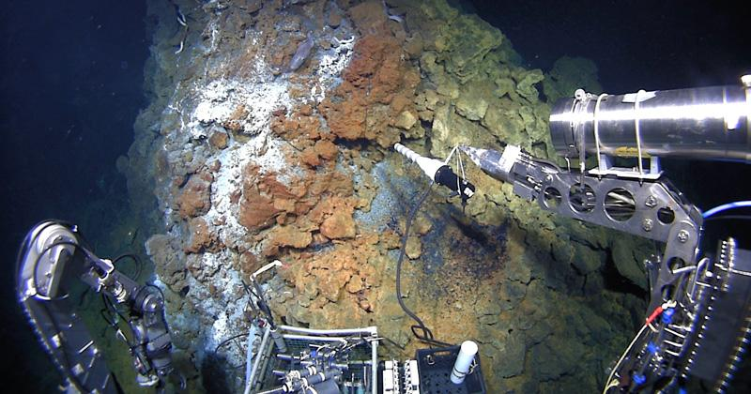
Image: Deep sea mining | Image courtesy: University of Delaware

The physical act of mining removes or disrupts the seabed, destroying habitats that have taken millennia to form. These operations generate noise and light, which can disrupt the behavior of deep-sea animals that rely on darkness and silence for survival.

- International Seabed Authority (ISA). (2010). Environmental management plan for the Clarion-Clipperton Zone (ISA Technical Study No. 5)
- MIDAS (Managing Impacts of Deep-sea Mining). (2016). D6.3 Synthesis report on the effects of sediment plumes on water column ecosystems.

Throughout the years, there are many conferences held to raise awareness about the sea. It is important that we nurture the sea as we are the beneficiary one. Some mentionable conferences and their goals are given below:

- United Nations Ocean Conference
First Held: 2017, New York, USA
Purpose: Focused on Sustainable Development Goal 14 (Life Below Water) to protect and sustainably use ocean resources

- Our Ocean Conference
First Held: 2014, Washington, D.C., USA
Purpose: Mobilizes action to combat marine pollution, climate change, and illegal fishing.

- World Ocean Summit
First Held: 2012, Singapore
Purpose: Organized by The Economist, it brings together leaders to discuss ocean sustainability and the blue economy.

- International Marine Protected Areas Congress (IMPAC)
First Held: 2005, Geelong, Australia.
Purpose: Discusses the establishment and management of Marine Protected Areas (MPAs).

- The UN Climate Change Conferences (COP, Annual)
First Held: 1995, Berlin, Germany (COP1)
Purpose: While focused on climate change, ocean health is increasingly a core discussion.

- World Ocean Conference
First Held: May 2009, Manado, Indonesia
Purpose: Raised global awareness of climate change impacts on oceans and led to the Manado
Ocean Declaration.

- Maldives Underwater Cabinet Meeting
Date: October 17, 2009, Maldives
Purpose: Maldives President Mohamed Nasheed and his ministers held a cabinet meeting underwater to highlight the threat of rising sea levels due to climate change.

- Deep-Sea Biology Symposium
First Held: 1977, Wormley, UK
Purpose: Brings marine scientists together to study deep-sea ecosystems and human impacts.

- International Coral Reef Symposium
First Held: 1967, Mandapam Camp, India.
Purpose: Focuses on coral reef conservation, restoration, and climate resilience.

- Ocean Visions Biennial Summit
First Held: 2021, Georgia Aquarium, Atlanta, USA.
Purpose: Brings together scientists, engineers, policymakers, and entrepreneurs to find solutions for ocean health and climate challenges.

